42 Northshore Highway
P.O. Box 574, Corner Brook, NL A2H 6G1
Phone: (709) 634-4774; Email: info@mountpatriciacemetery.com
Office Hours: 8:30am – 4:30pm Monday-Friday (closed for lunch 12-1)

Mount Patricia Cemetery Association is holding a Silent Sealed Bid Auction from March 30 at 8:30am until April 6 at 4:30pm. No bids will be accepted after April 6 at 4:30pm.
All bids must be in writing clearly stating the item and bid amount along with your name, address, and contact information (telephone and email).
The bid is to be placed in a sealed envelope; the envelope must be addressed to:
Mount Patricia Cemetery Association
PO Box 574
Corner Brook, NL A2H 6G1
RE: AUCTION

List of Auction Items:

Auction Item 1:
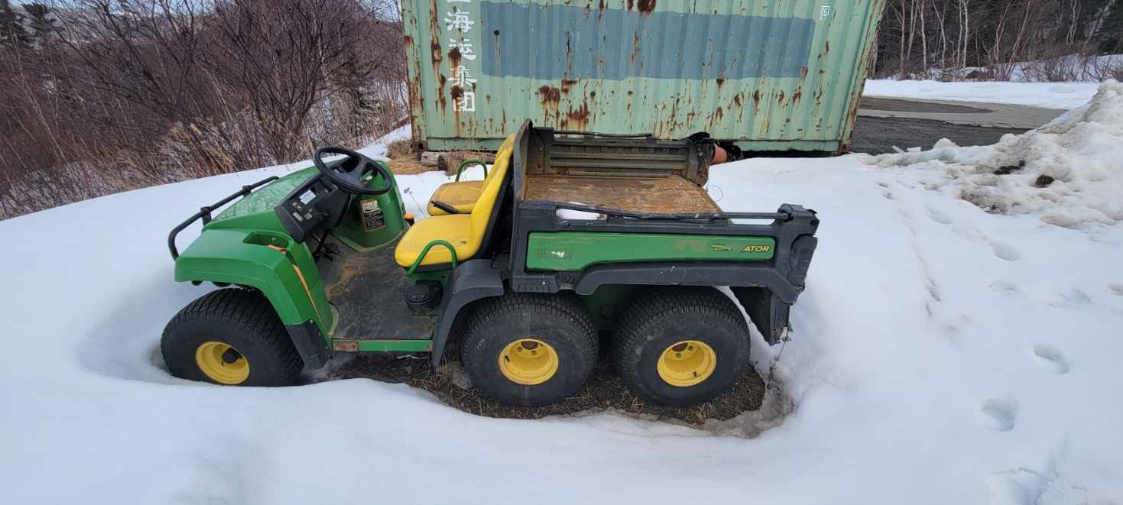
2010 John Deere 6 x 4 Gator Model M06x4HD050447. Has 3500hours. New tires, new battery. Needs new Wiring harness. Not in working order.

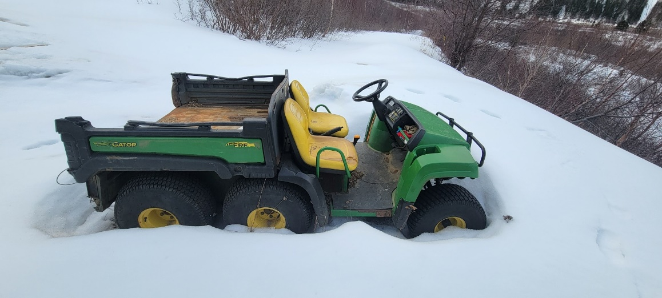
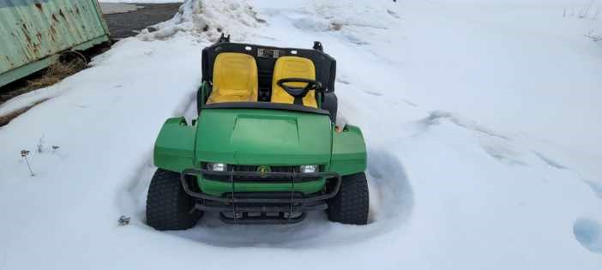
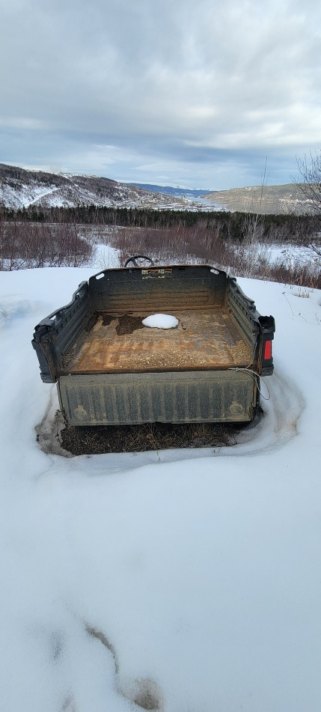
Auction Item 2:
2021 Stihl FS38 whipper snipper. Hours unknown. In good working order.
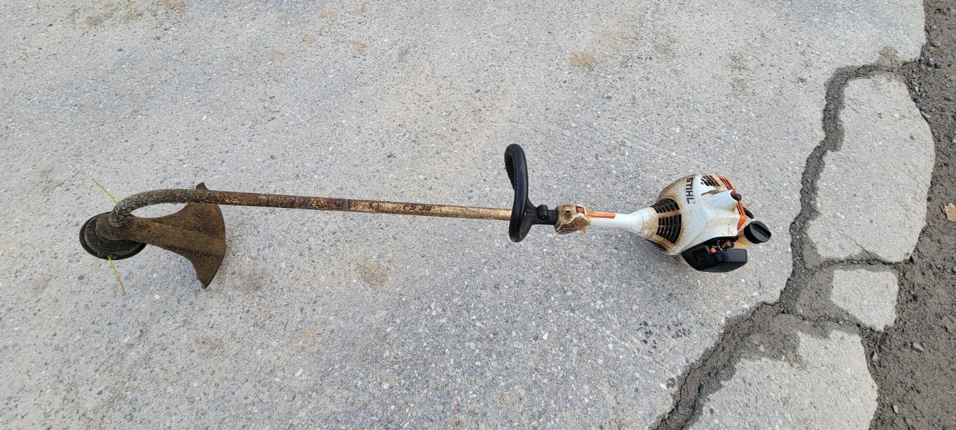
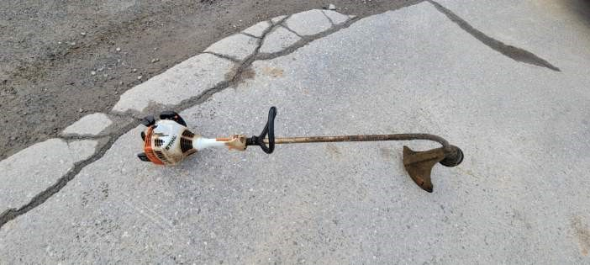
Auction Item 3:
2017 Stihl FS38 Whipper Snipper. Hours unknown. In good working order.
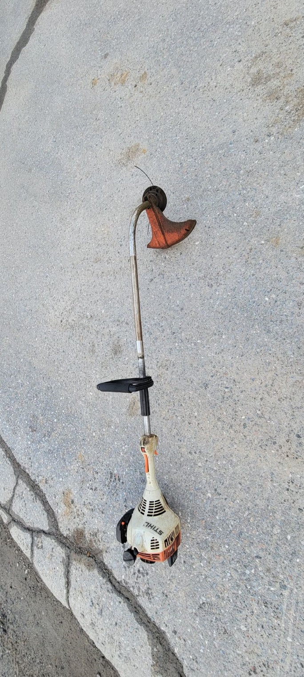
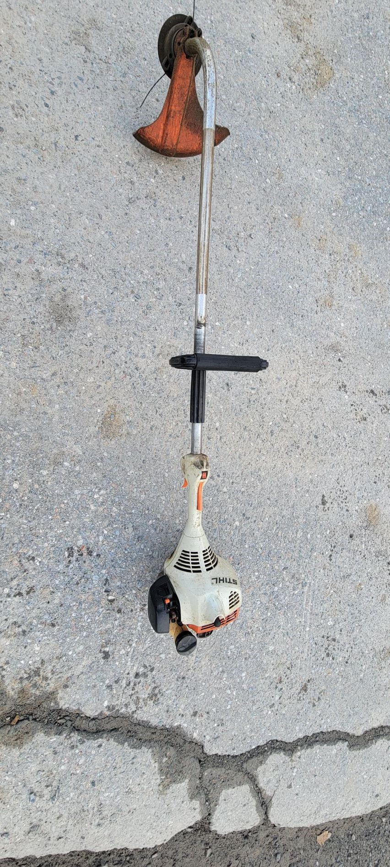
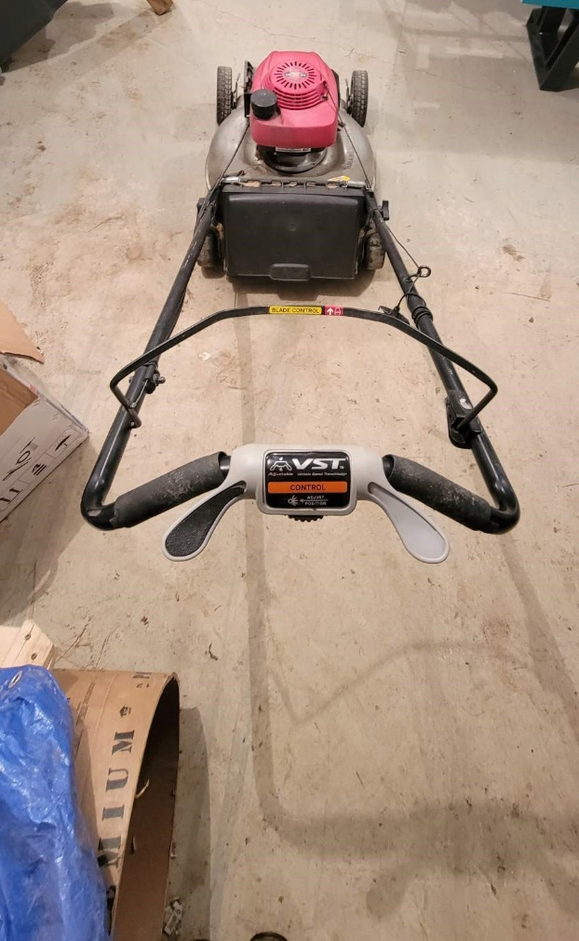
Auction Item 4:
2010? Honda self-propelled Lawn mower. Working order unknown.

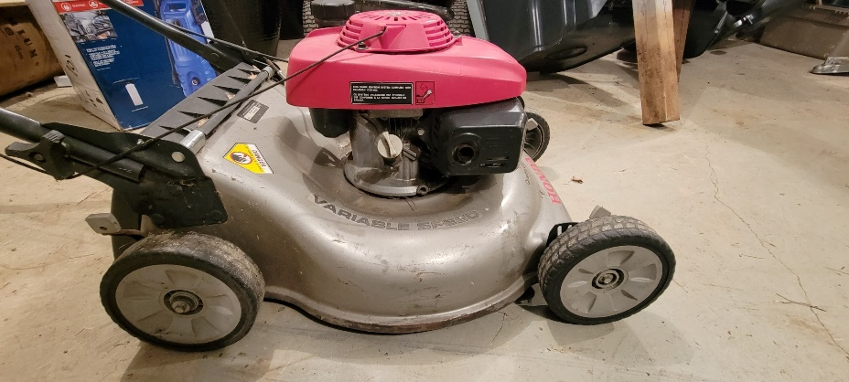
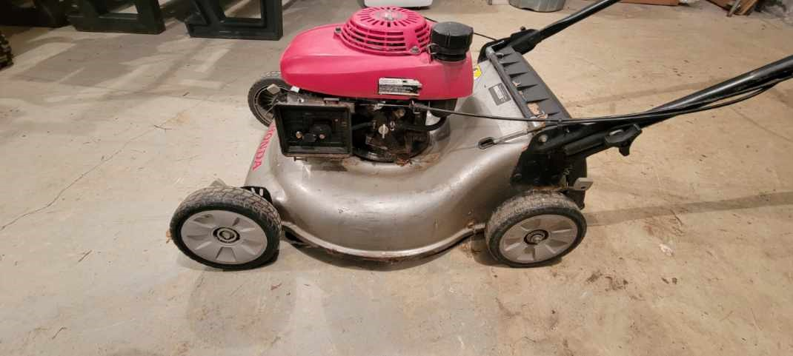
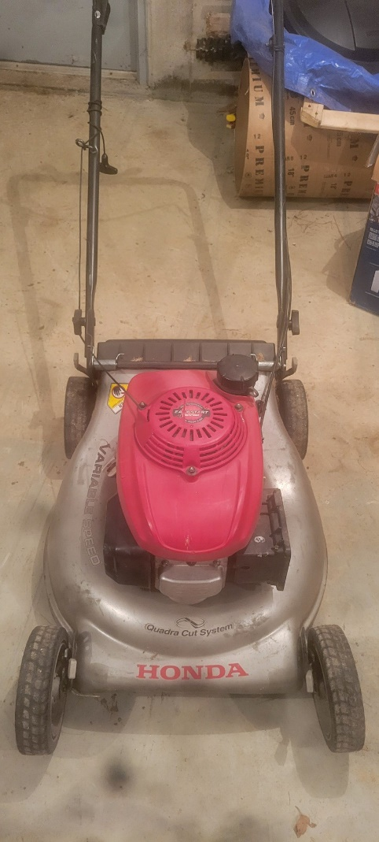

Auction Item 5:
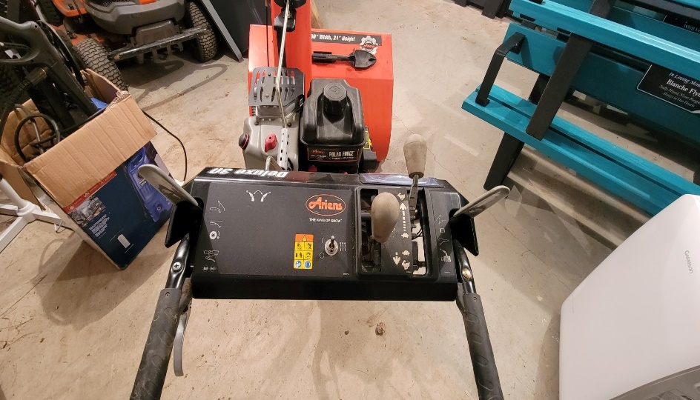
2017 Gas Ariens Snowblower 30” Width, 21” height cut. In excellent working order.
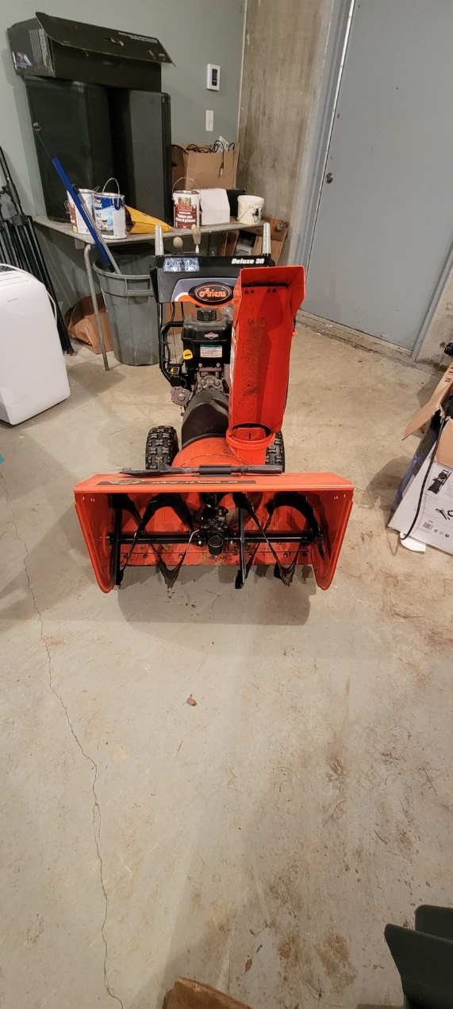
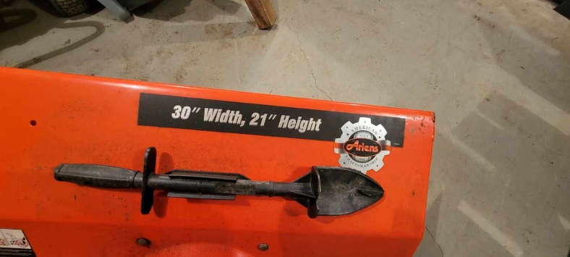
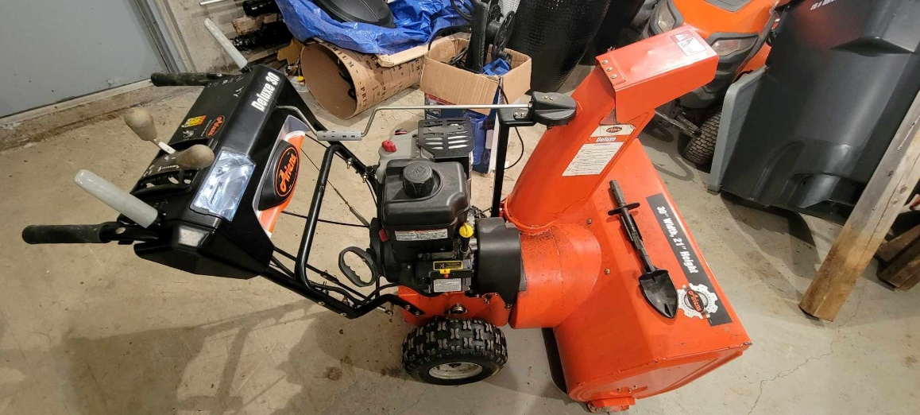
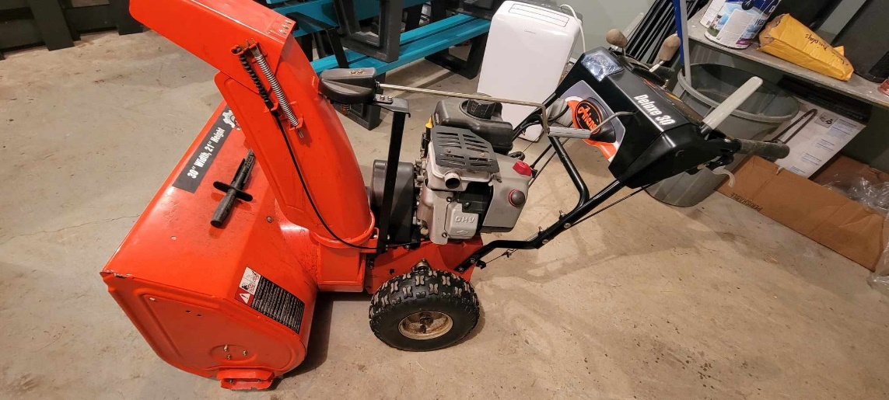

Auction Item 6:
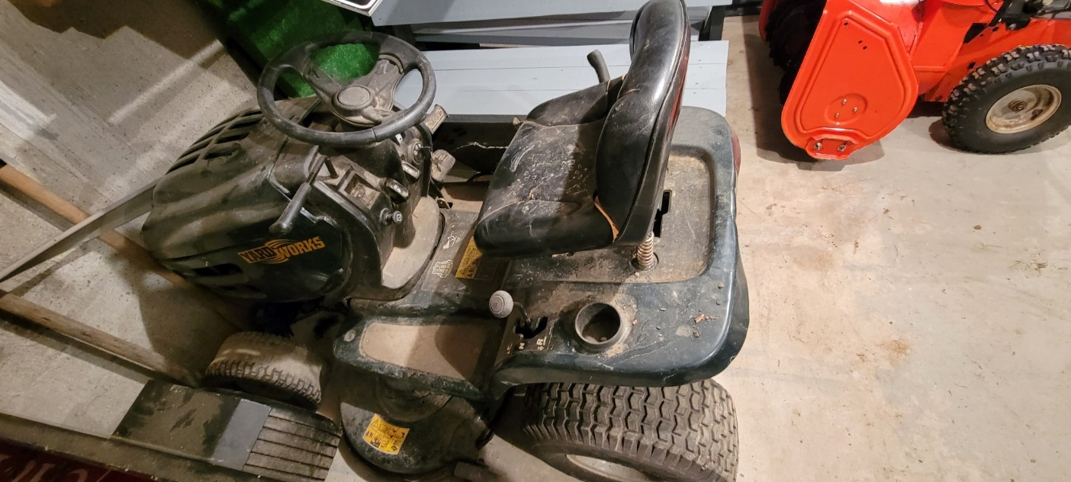
Yardworks ride on Lawn mower. Working order unknown.

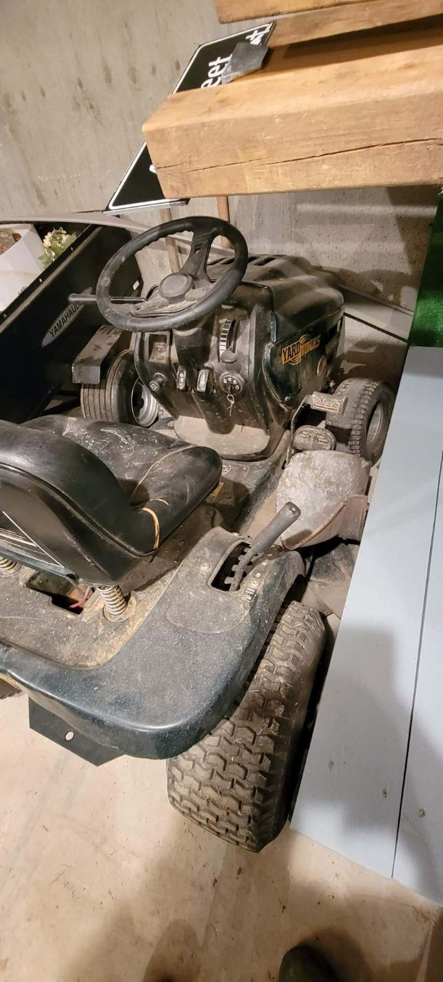
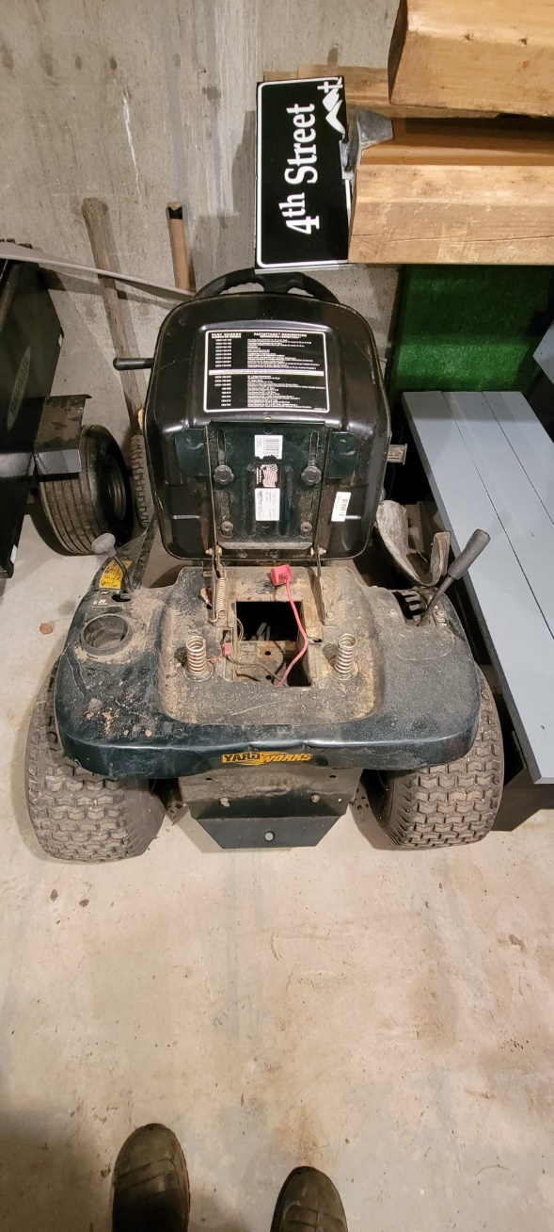
Auction Item 7:
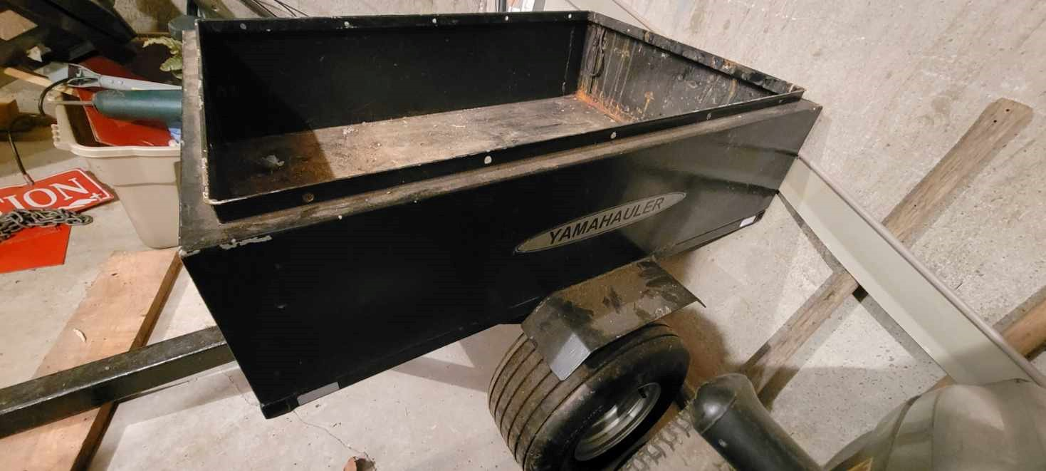
Yamahauler dump cart for yardwork. In excellent working order.

